# Pega Simulator [Technical Documentation]

## Pega Simulator:

* It’s a simulator for the MOMRA customer validation service.
* Contains 3 endpoints in com.incorta.pega.webapi.PegaServlet in incorta.simulators project.

## Pega Simulator workflow:

1- The home page → /incorta.simulators/pega/home

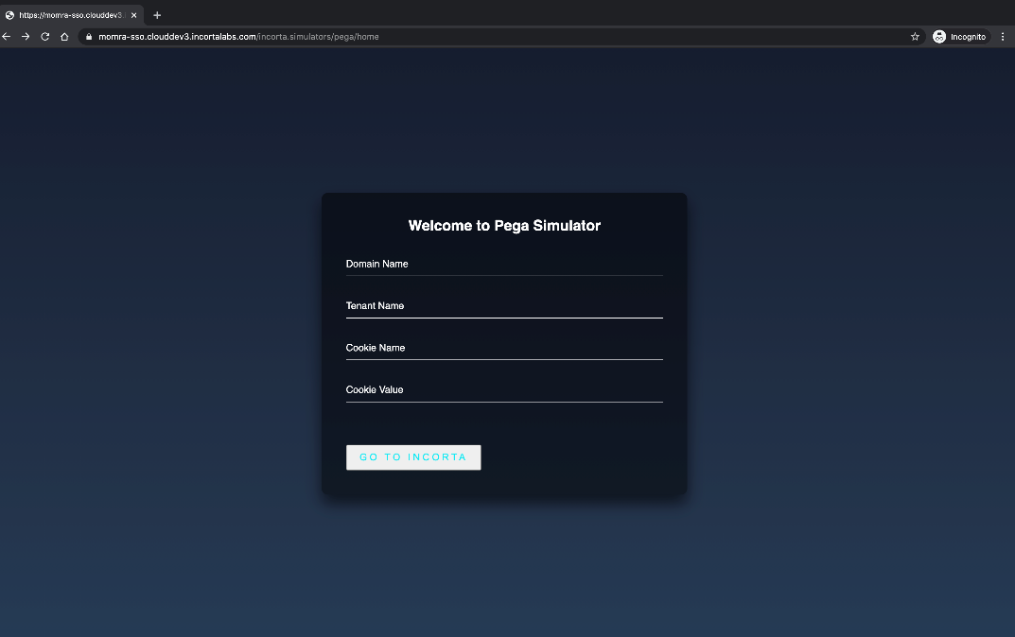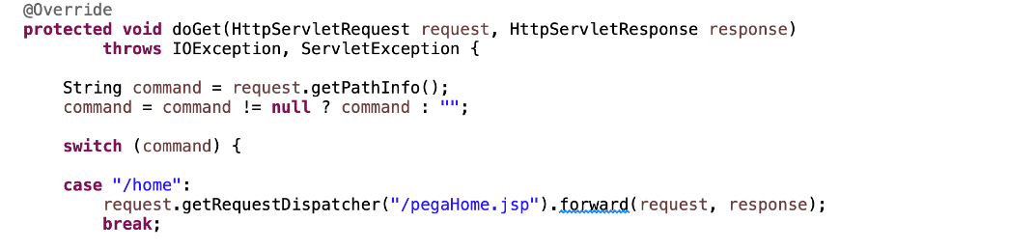

2- When clicking on (GO TO INCORTA), will go to the second endpoint →/incorta.simulators/pega/incorta

to prepare the Incorta request with the expected cookie

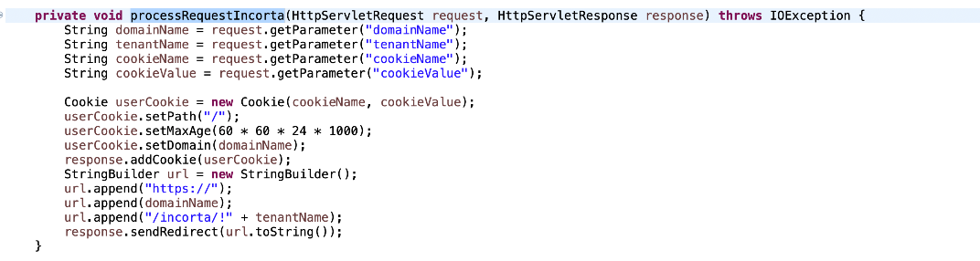

3- The last one is the validation endpoint → /incorta.simulators/pega/validate

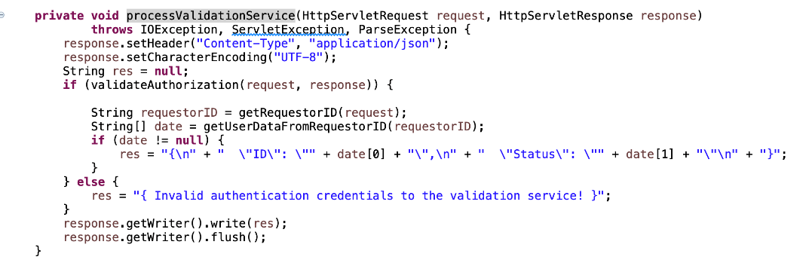

* The expected request body:
* {
* "RequestData":{
* "RequestorID": {UserLoginName:UserStatus}
* }

}

* The response body will be:
* {
* "ID":{loginName},
* "Status": [Active| Inactive | Invalid]

}